



**ECEN428**

**Hotel Reservation System**

**By:**

|  |  |
| --- | --- |
| **Mohamed Shawky** | **202000218** |
| **Ahmed Ayman** | **202000689** |
| **Mohab Mohamed** | **202000083** |

**Under supervision of**

**Dr. Mourad Raafat**

**Eng. Hanya Mostafa**

**Table of Contents**

1. Introduction 4

1.1. Purpose 4

1.2. Project Scope 4

1.3. Used Technologies 4

1.4. Intended Audience 4

2. Overall Description 5

2.1 Product Perspective 5

2.1.1. Product Function 5

2.2. User Characteristics 5

2.3. Constraints 5

2.4. Assumptions and Dependencies 6

3. Functional Requirements: 6

3.1. User Class 1: Staff 6

3.1.1. Functional Requirements 6

User Registration: 6

3.1.2. Functional Requirements 6

Room Management: 6

3.1.3. Functional Requirements 7

Reservation Management: 7

3.1.4. Functional Requirements 7

Check-in/Check-out: 7

3.1.5. Functional Requirements 7

Payment Processing: 7

3.1.7. Functional Requirements 7

View Guest report: 7

4. Non-Functional Requirements 8

4.1. Usability: 8

4.2. Performance: 8

4.3. Scalability: 8

4.4. Availability: 8

5.Interface 9

5.1 System Interface 9

Login Page. 9

Home Page: 9

Check In 10

Check Out 10

10

Cancel Booking. 11

Rooms 11

Guests 12

Account Management: 12

Add user 13

View Users 14

6. Diagrams 15

6.1. Use case Diagram 15

6.1.1. Use case scenarios: 15

6.2. Class Diagram: 22

6.3. Sequence Diagram: 23

7. Testing 24

8. Links 29

8.1. Github Link 29

8.2.Gitlab Link 29

# Introduction

## Purpose

The purpose of this document is to outline the functionalities and specifications of the hotel reservation system. It aims to define the system's features, user interface, and overall purpose, including testing criteria, performance expectations, and constraints.

## Project Scope

The hotel reservation system application provides an easy and effiecient way to reserve in a hotel. All of the user’s data are registered and stored which makes it easier for further reservations. The application contain features such as check in, checkout, rooms, room booking and many more.. The application's primary goal is to allow easy, fixed and reliable reservations for the users.

## Used Technologies

Desktop Application to Manage the reservations and Guest Check-in or Check-Out Using JavaFX and SQL Database.

## Intended Audience

* Customers: To book accommodation, view available options, and experience a user-friendly reservation process.
* Hotel staff: To streamline booking processes, manage reservations efficiently, and enhance guest experience.
* Software Tester: To implement, maintain, and troubleshoot the hotel reservation system, ensuring seamless functionality.
* Project Manager: To oversee system performance, assess analytics, and make strategic decisions based on reservation date

# 2. Overall Description

## 2.1 Product Perspective

The hotel reservation system is a software application designed to facilitate booking and managing hotel accommodations It provides a centralized platform for both customers and hotel staff to efficiently handle reservations, check-ins, check-outs, room assignments, and other related tasks.

## 2.1.1. Product Function

The primary function of the hotel reservation system is to facilitate the booking process for guests. This includes features such as room availability checks, booking management, payment processing. The system also supports room inventory management, reporting, and analytics to assist hotel staff in optimizing occupancy rates and revenue generation.

## 2.2. User Characteristics

* Staff: have the knowledge to use the application efficiently to fulfill the scope and assist the customers to reserve his desired room .
* Admin: have the ability to register new staff into the application and delete users.

## 2.3. Constraints

* Sign-in and password will be required to identify whether the user is an admin or a staff user.
* Room Inventory Management: The availability of rooms is constrained by factors such as existing bookings and reservations.
* Room Configuration: Each room has specific configurations and features, such as bed types.
* The staff user can't access things that the admin user can access

## 2.4. Assumptions and Dependencies

* Internet Connectivity: Users require internet access to interact with the system through web browsers or mobile applications.
* Accurate Inventory: Availability of rooms and rates depends on timely updates from the hotel's property management system or central reservation system.
* Payment Processing: Integration with secure payment gateways is assumed for handling financial transactions.
* User Training: Users, particularly front desk staff, require training and support to utilize the system effectively and address common issues.

# 3. Functional Requirements:

## 3.1. User Class 1: Staff

## 3.1.1. Functional Requirements

### User Registration:

Staff members should be able to create accounts for Guests on the hotel reservation system. They should provide necessary information such as personal details, contact information.

## 3.1.2. Functional Requirements

### Room Management:

Staff should be able to manage room availability and details within the system. This includes adding new rooms, updating room information (e.g., availability, rates), and removing rooms from inventory when necessary.

## 3.1.3. Functional Requirements

### Reservation Management:

Staff should have access to view and manage reservations made by users. This includes checking reservation details, modifying bookings (e.g., changing dates, room type), and canceling reservations as needed.

## 3.1.4. Functional Requirements

### Check-in/Check-out:

Staff should be able to process check-ins and check-outs efficiently. This involves verifying guest information, assigning rooms, collecting payments, and issuing receipts.

## 3.1.5. Functional Requirements

### Payment Processing:

Staff should be able to process payments for reservations made by users. This includes entering payment details, authorizing transactions, and handling any payment-related issues that may arise.

## 3.1.7. Functional Requirements

### View Guest report:

Staff should have access to see Guest reports. This includes reports on Guest info.

# 4. Non-Functional Requirements

## 4.1. Usability:

The reservation system should provide a simple as well as an easy-to-use interface for the staff to make the reservation process efficient and simple.

## 4.2. Performance:

The system should be fast in response and without having any response delays, especially at peak and crowded hours. The efficient and fast response is required to quickly access and manage reservations, check rooms, check the guest’s information and to process the transactions without any delays or errors.

## 4.3. Scalability:

The system should be scalable to accommodate an increasing number of staff users and reservation requests over time. It should handle growing data volumes and user interactions without compromising performance or responsiveness, ensuring seamless operation as the hotel business expands.

## 4.4. Availability:

The reservation system must be always available to staff members that need to access it at any time. The system’s availability is important and required to ensure the guests satisfaction and provide the staff with reliable access whenever is needed.

# 5.Interface

## 5.1 System Interface

### Login Page: the staff opens log in page to sign in his account.

### Home Page: The home page acts as a menu to all options and features that the application offers.

### 

### Check In: In the check in page, the staff is required to enter all the information regarding the user as well as the billing information. After successful registration the room ID will be available for the user.

## 

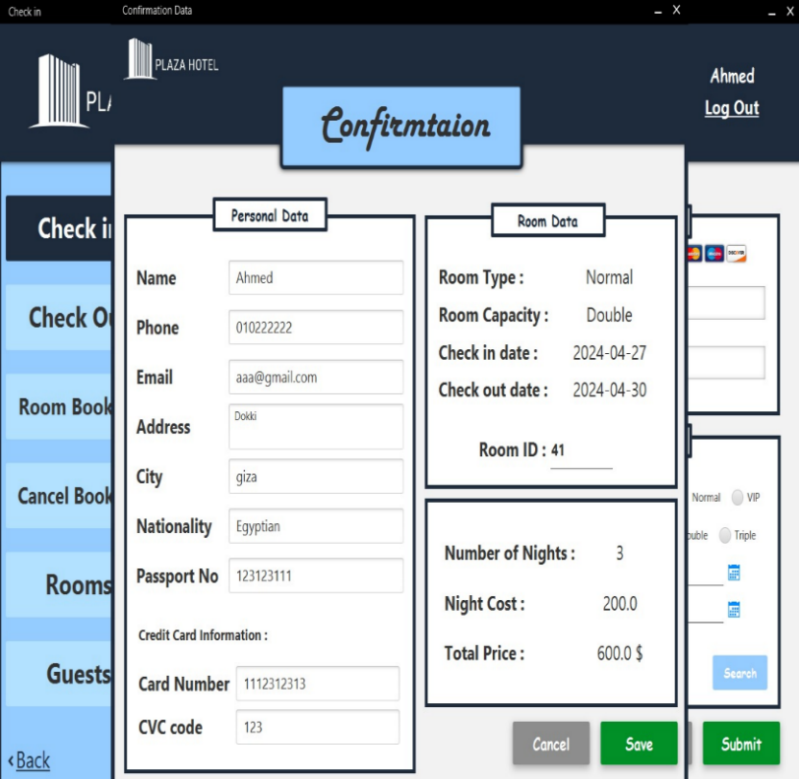

### 

### Check Out: The checkout page used for customers leaving the hotel.

### 

### Cancel Booking: We cancel the booking for the guest.

### 

### Rooms: In the rooms page it shows the all the details regarding the room class, the room number, room date, and availability.

### 

### 

### Guests: Here is the guest’s full information after he/she books.

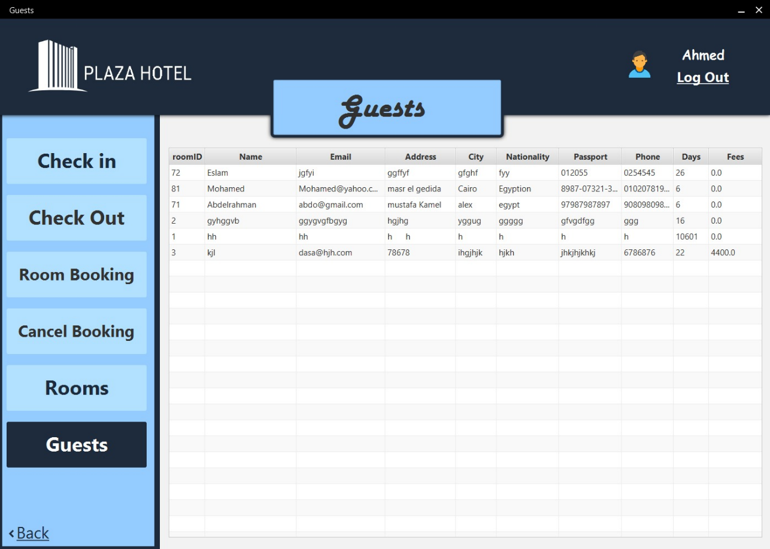

### Account Management:

### Add user: In the “add user page” it shows the authority of the hotel admins or application admins to add and recruit new staff or to add a new admin.

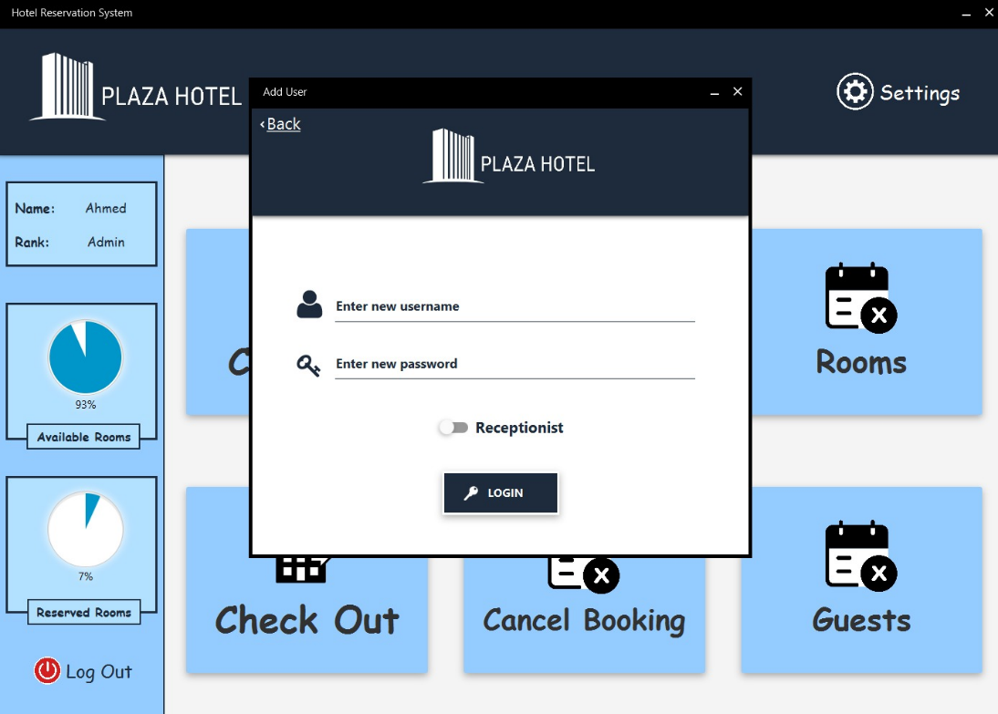

#### **Delete User:** In the delete user page it also shows the authority of admins to remove existing staff from the system.

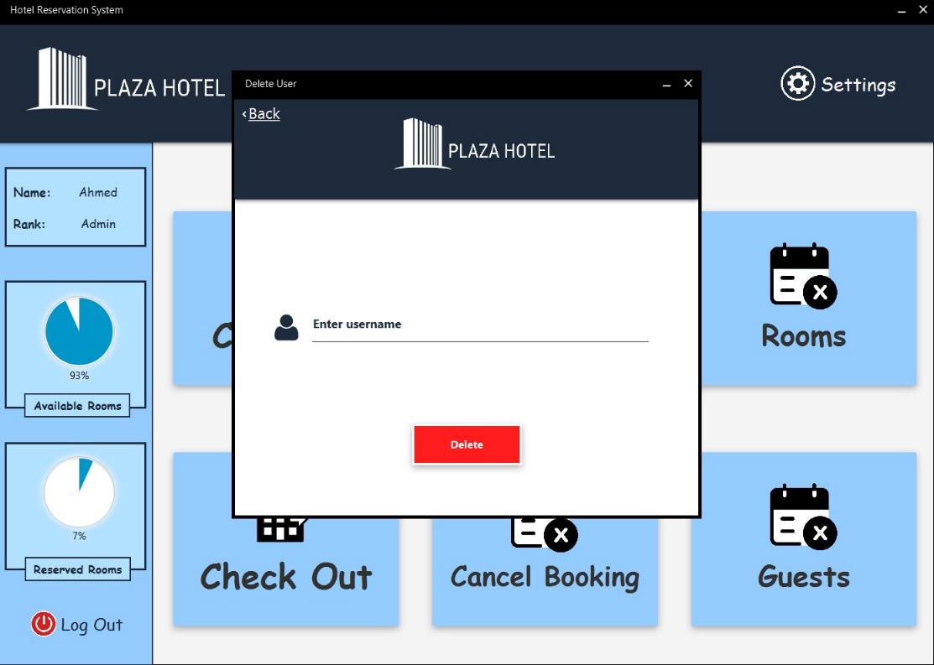

## A screenshot of a hotel Description automatically generatedView Users: In the view user page, it show all the staff members and their ranks between staff or admin.

# 6. Diagrams

## 6.1. Use case Diagram

### 6.1.1. Use case scenarios:

**Use Case 1**

|  |  |
| --- | --- |
| Staff Registration | |
| **Use case Name** | Staff Registration |
| **Actors** | Admin |
| **Main success scenario** | 1. Admin navigates to the staff registration section. 2. System asks the admin to provide the new staff member’s information Username, Password. 3. Admin provides the system with the required information. 4. Admin clicks on the register button. 5. System creates the new staff member’s account. |
| **Exceptions** | 3a. Admin clicks on the register button without filling in all the required information.  4a. username is already registered. |
| **Actions** | 3.1. System displays to the admin an alert “Please fill in all the required fields”.  3.2. Admin fills out the missing information.  4.1. System displays a message to the admin: “Username exists.”  4.2. Admin enters another username. |
| **Pre-Condition** | * Admin is logged into the system and has the necessary permissions to register a new staff member. |
| **Post Condition** | * Another staff member is added to the system. * Staff members are successfully registered. * Staff member’s information is stored in the database. |

**Use case 2**

|  |  |
| --- | --- |
| Login | |
| **Use case Name** | Login |
| **Actors** | Staff / Admin |
| **Main success scenario** | 1. The admin is required to add the username and the passwords of new staff recruited. 2. Admin chooses to create a new account. 3. System asks the user to give their information: username, password (at least 8 characters), email (unregistered email), phone number, address, photo (optional). 4. Admin gives the system the required information. 5. Admin clicks on the add staff button. 6. System checks that the email is not registered. 7. System checks that the username is not registered. 8. System creates the account. 9. The staff logins into the hotel system with the given username and password to serve the guests. |
| **Exceptions** | 5a. Admin clicks on the add staff button without filling all of the required information.  6a. Email is already registered.  7a. Username is already registered. |
| **Actions** | * 1. System display to the admin an alert “Please fill in all the required fields”.   2. Admin fills the missing information.   3. System display to the Admin “Email already registered”.   4. System display to the Admin “Username already exist”.   5. Admin enters another username. |
| **Pre-Condition** | * Staff has to access the hotel application. |
| **Post Condition** | * Another guest is added to the system. * Guest is successfully registered. * Guest information is stored in the database. |

**Use Case 3**

|  |  |
| --- | --- |
| Registration | |
| **Use case Name** | Registration |
| **Actors** | Staff |
| **Main success scenario** | 1. Staff greets the guest and take their info. 2. Guests provides the required information including their name , phone number , age , payment method , room to be registered and the time willing to be spent in the hotel. 3. Staff reviews the completed form to ensure all necessary fields are filled out. 4. Staff checks if the patient's email is already registered in the system. 5. Staff confirms the registration and adds the guest information into the database. |
| **Exceptions** | 4a. If the guest email is already registered, staff asks the guest to confirm their identity and updates the contact details if necessary.  5a. if the guest is registered to the first time , the staff asks them for all of their information. |
| **Actions** | * 1. 4.1.Staff searches for the patient's email in the practice management software.   2. 5.1.Staff enters all new guest information to the database and records it. |
| **Pre-Condition** | * Guest has completed the new guest registration form |
| **Post Condition** | * A new guest record is created in the hotel application. |

**Use Case 4**

|  |  |
| --- | --- |
| checkin/checkout | |
| **Use case Name** | Check-in/check-out |
| **Actors** | Staff |
| **Main success scenario** | 1. Guest arrives at the hotel to check in. 2. Receptionist logs into the hotel management system using their secure credentials. 3. Staff searches for the guest's reservation by entering their name, reservation number, or other identifying information. 4. System displays the guest's reservation details, including room type, check-in and check-out dates, and any special requests or preferences. 5. Receptionist confirms the reservation details with the guest and completes the check-in process. 6. Staff updates the hotel management system to mark the guest as checked in, ensuring room availability is accurately reflected. 7. Guest checks out at the end of their stay. 8. Staff logs into the hotel management system and retrieves the guest's billing information. 9. Staff reviews the charges with the guest and processes payment. 10. Staff updates the hotel management system to mark the room as checked out and ready for cleaning. |
| **Exceptions** | 4a. f the patient's record is not found in the system, receptionist asks the patient for additional identifying information.  6a. If the requested information is sensitive or confidential, receptionist consults with the practice manager or physician before releasing it |
| **Actions** | 3a. If the guest's reservation is not found in the system, receptionist asks the guest for additional identifying information.  5a. If the guest arrives early and the room is not ready, receptionist offers alternatives such as storing luggage or access to hotel amenities until the room is available.  9a. If the guest disputes any charges, receptionist consults with the hotel manager or relevant department before finalizing the bill. |
| **Pre-Condition** | * Receptionist has the necessary permissions and access rights to view and manage all guests' reservations in the hotel's management system. |
| **Post Condition** | * Guest is successfully checked in or out, ensuring accurate and up-to-date room availability and billing information is maintained in the hotel management system. |

**Use Case 5**

|  |  |
| --- | --- |
| Room Management | |
| **Use case Name** | Room Management |
| **Actors** | Staff |
| **Main success scenario** | 1. Staff logs into the system. 2. Staff navigates to the room management section. 3. Staff views the list of available rooms. 4. Staff selects a room to manage. 5. Staff performs one or more of the following actions:   Assign room to a guest  Mark room as unavailable  Update room details   1. Staff saves the changes made. |
| **Exceptions** | 4a. Staff attempts to add a new room without providing all required information.  4b. Staff tries to update room information for a non-existing room.  4c. Staff attempts to remove a room that is currently booked |
| **Actions** | 4.1. System displays appropriate alerts or notifications for each exception scenario.  4.2. Staff provides necessary information or confirms actions as per the exception scenario. |
| **Pre-Condition** | * Staff is logged in to the system and has access to the room management. |
| **Post Condition** | * Room inventory is updated according to the actions performed by the staff. * Staff can view the updated room information in the system. * Any changes made are reflected in the hotel's reservation and booking system. |

Use Case 6

|  |  |
| --- | --- |
| Access Control | |
| **Use case Name** | Access Control |
| **Actors** | Admin |
| **Main success scenario** | 1. Admin accesses the access control interface. 2. Admin selects the option to manage user access rights. 3. System displays a list of users and their current access privileges. 4. Admin chooses one or more of the following access control tasks:   Grant access: Assigning specific access rights to users.  Revoke access: Removing access rights from users.  Modify access: Updating existing access rights for users.   1. Admin selects the user(s) for whom access rights will be managed. 2. Admin configures the access rights for the selected user(s) based on their roles and responsibilities. 3. System applies the configured access rights to the respective user accounts. 4. Admin verifies that the access rights are correctly assigned or revoked. |
| **Exceptions** | 4a. Admin attempts to modify access rights without appropriate privileges.  5a. Admin selects a non-existent user for access control.  6a. Admin configures access rights inconsistent with user roles or organizational policies. |
| **Actions** | * 1. 4.1. System provides appropriate alerts or notifications for each exception scenario.   2. 5.1. System verifies the existence of the selected user and prompts the admin accordingly.   3. 6.1. System alerts the admin about potential security risks or policy violations.   4. 6.2. Admin adjusts access rights to mitigate security risks or policy violations. |
| **Pre-Condition** | * Admin has privileged access to the access control interface. |
| **Post Condition** | * Access rights are accurately configured for users based on their roles and responsibilities. * Users can access only the resources and functionalities appropriate for their roles. * Admin receives confirmation of successful access rights configuration. |

**Use Case 7**

|  |  |
| --- | --- |
| View Users | |
| **Use case Name** | View Users |
| **Actors** | Admin |
| **Main success scenario** | 1. Admin logs into the system. 2. Admin navigates to the user management section. 3. Admin selects the option to view all users. 4. System retrieves the list of all users (both admin and staff) from the database. 5. System displays the list of users with the following details: Username, Password. |
| **Exceptions** | 3a. System encounters an error while retrieving the users list. |
| **Actions** | 3.1. System displays an error message: “Unable to retrieve user list. Please try again later.”  3.2. Admin retries or contact’s technical support. |
| **Pre-Condition** | * Admin is logged into the system and has the necessary permissions to view user details. |
| **Post Condition** | * Admin can see the list of all users (both admin and staff) with their usernames and passwords. * User details are displayed on the screen. |

**Use Case 8**

|  |  |
| --- | --- |
| View Guest Report | |
| **Use case Name** | View Guest Report |
| **Actors** | Staff |
| **Main success scenario** | 1. Staff logs into the system. 2. Staff navigates to the guest Section. 3. System displays the guest report with the following details: Guest Name, Nationality, Email Address, City, Passport Number, Phone Number, Number of Days Stayed, Fees. |
| **Exceptions** | 3b. System encounters an error while retrieving the guest details. |
| **Actions** | 3.1. Staff retries or contact’s Admin For support. |
| **Pre-Condition** | * Staff is logged into the system and has the necessary permissions to view guest Details. |
| **Post Condition** | * Staff can see the detailed report of guests for the specified room. * Guest details are displayed on the screen. |

## 6.2. Class Diagram:

## 6.3. Sequence Diagram:

## 

# 7. Testing

|  |  |
| --- | --- |
| **Project Name:** Hotel Reservation System | |
| **Test Case Template** | |
| **Test Case ID:** Hotel_1 | **Test Designed by:** Mohamed Shawky |
| **Test Priority (Low/Medium/High):** High | **Test Designed date:** 25/4/2024 |
| **Module Name:** Staff registration | **Test Executed by:** Mohamed Shawky |
| **Test Title:** Staff registration Process | **Test Execution date:** 27/4/2024 |
| **Description:** register guests into the hotel |  |
|  |  |
|  |  |
| **Pre-conditions:** Guest has completed the new guest registration form | |
| **Dependencies: the application must be deployed and running correctly on the target environment.** | |

|  |  |  |  |  |  |  |
| --- | --- | --- | --- | --- | --- | --- |
| **Step** | **Test Steps** | **Test Data** | **Expected Result** | **Actual Result** | **Status (Pass/Fail)** | **Notes** |
| 1 | Open The App |  | Able to see home page | Home page is displayed | Pass |  |
| 2 | Navigate to the registration page |  | Registration page should be accessible | Registration page is accessible | Pass |  |
| 3 | Fill in the guest details | Name: jane smith, email:jane@gmail.com | User should be able to enter all registration details | User enters all registration details | Pass |  |
| 4 | Create username and password | Username: jane smith  Password: jane123 | User should be able to create username and password | User creates a username and a password | Pass |  |
| 5 | Accept terms and conditions |  | User should be able to accept terms and conditions | User accepts terms and conditions | Pass |  |

**Post-conditions:**

A new guest record is created in the hotel application.

|  |  |
| --- | --- |
| **Test Case ID:** Hotel_2 | **Test Designed by:** Ahmed Ayman |
| **Test Priority (Low/Medium/High):** High | **Test Designed date:** 25/4/2024 |
| **Module Name:** guest check in and check out | **Test Executed by:** Ahmed Ayman |
| **Test Title:** guest checking in and out | **Test Execution date:** 27/4/2024 |
| **Description:** guests reserving and leaving |  |
|  |  |
|  |  |
| **Pre-conditions:** Receptionist has the necessary permissions and access rights to view and manage all guests' reservations in the hotel's | |
| **Dependencies: The hotel management application must be deployed, running correctly, and accessible.** | |

|  |  |  |  |  |  |  |
| --- | --- | --- | --- | --- | --- | --- |
| **Step** | **Test Steps** | **Test Data** | **Expected Result** | **Actual Result** | **Status (Pass/Fail)** | **Notes** |
| 1 | Open The App |  | Able to see home page | Home page is displayed | Pass |  |
| 2 | Navigate to the check in/check out module |  | Module should be open and ready for interaction | Module opens successfully | Pass |  |
| 3 | Search for guest reservation | Name: john williams, reservation ID: 98465 | Reservation details should be displayed | Reservation details are displayed | Pass |  |
| 4 | Confirm reservation and check in guest | Room number: 101 | Guest should be checked in and room assigned | Guest checked in and room assigned | Pass |  |
| 5 | Process guest check out | Name: john Williams  Room number: 101 | Billing information should be retrieved | Billing information retrieved | Pass |  |

**Post-conditions:**

Guest is successfully checked in or out, ensuring accurate and up-to-date room availability and billing information is maintained in the hotel management system.

|  |  |
| --- | --- |
| **Test Case ID:** Hotel_3 | **Test Designed by:** Ahmed Ayman |
| **Test Priority (Low/Medium/High):** High | **Test Designed date:** 25/4/2024 |
| **Module Name:** Staff Login | **Test Executed by:** Ahmed Ayman |
| **Test Title:** Staff Login Process | **Test Execution date:** 25/4/2024 |
| **Description:** Test the App login page |  |
|  |  |
|  |  |
| **Pre-conditions:** User has valid username and password | |
| **Dependencies:** Backend validation to ensure uniqueness and correctness of the provided email during registration. | |

|  |  |  |  |  |  |  |
| --- | --- | --- | --- | --- | --- | --- |
| **Step** | **Test Steps** | **Test Data** | **Expected Result** | **Actual Result** | **Status (Pass/Fail)** | **Notes** |
| 1 | Open The App |  | Able to see login Page | As expected, | Pass |  |
| 2 | Click on login page | Staff User= [example@gmail.com](mailto:example@gmail.com) | User should be able to see the login page | User is navigated to the login page | Pass |  |
| 3 | Fill in valid user details | Password: 1234 | User should be able to fill in the login details | User fills in the details | Pass |  |
| 4 | Click on Login button |  | User should be logged in and navigated to the dashboard | User is navigated to the dashboard | Pass |  |
| 5 | Open App |  | Application should open and be ready for user interaction | Application opens successfully | Pass |  |

**Post-conditions:**

The staff user is successfully logged into the system and can access all functionalities available on the staff dashboard.

|  |  |
| --- | --- |
| **Test Case ID:** Hotel_4 | **Test Designed by:** Mohab Mohamed Ali |
| **Test Priority (Low/Medium/High):** Medium | **Test Designed date:** 25/4/2024 |
| **Module Name:** Staff View Guest Report | **Test Executed by:** Mohab Mohamed Ali |
| **Test Title:** Staff View Guest Report | **Test Execution date:** 25/4/2024 |
| **Description:** Test the if staff can view the guest report. |  |
|  |  |
|  |  |
| **Pre-conditions:** Guest data must be present in the database and Staff user has the necessary permissions to view guest reports | |
| **Dependencies:** Database must be updated with relevant guest information. | |

|  |  |  |  |  |  |  |
| --- | --- | --- | --- | --- | --- | --- |
| **Step** | **Test Steps** | **Test Data** | **Expected Result** | **Actual Result** | **Status (Pass/Fail)** | **Notes** |
| 1 | Login to the system as a staff user | User: [example@gmail.com](mailto:example@gmail.com)  Password: 1234 | User should be logged in and navigated to the staff dashboard | As expected, | Pass |  |
| 2 | Navigate to the Guest Report section |  | User should be able to see the Guest Report option | As expected, | Pass |  |
| 3 | Click on Guest Report |  | User should be navigated to the Guest Report page | As expected, | Pass |  |
| 4 | See Guest Report |  | Guest information should be displayed | As expected, | Pass |  |
| 5 | Verify guest information displayed |  | Guest details should match the data in the database | As expected, | Pass |  |

**Post-conditions:**

The staff user can view all details related to the guest information such as name, nationality, email, address, city, passport, phone number, number of days stayed, and fees are displayed accurately.

|  |  |
| --- | --- |
| **Test Case ID:** Hotel_5 | **Test Designed by:** Mohab Mohamed Ali |
| **Test Priority (Low/Medium/High):** High | **Test Designed date:** 25/4/2024 |
| **Module Name:** Admin View Users | **Test Executed by:** Mohab Mohamed Ali |
| **Test Title:** Admin View Users Accounts | **Test Execution date:** 25/4/2024 |
| **Description:** Test if the admin attempts to view users is valid |  |
|  |  |
|  |  |
| **Pre-conditions:** Admin user has the necessary permissions to view user information. | |
| **Dependencies:** Database must be accessible to retrieve user details. | |

|  |  |  |  |  |  |  |
| --- | --- | --- | --- | --- | --- | --- |
| **Step** | **Test Steps** | **Test Data** | **Expected Result** | **Actual Result** | **Status (Pass/Fail)** | **Notes** |
| 1 | Login to the system as an admin user | User: [example@gmail.com](mailto:example@gmail.com)  Password: 1234 | User should be logged in and navigated to the admin dashboard | As expected, | Pass |  |
| 2 | Navigate to the View Users section |  | User should be able to see the View Users option | As expected, | Pass |  |
| 3 | Click on View Users |  | User should be navigated to the View Users page | As expected, | Pass |  |
| 4 | System retrieves user data |  | System should display users accounts | No error message displayed | Fail |  |
| 5 | See all users data |  | System should display users: Username and Password. | No Data Appears | Fail |  |

**Post-conditions:**

Ensure that the database connectivity is working fine.

# 8.Links

## 8.1.GitHub Link:

## <https://github.com/MoShawky10/ECEN428-Project>

## 8.2.Gitlab Link:

## <https://gitlab.com/uzumaki2722608/ecen428-project>